**Adam Martin Bio**

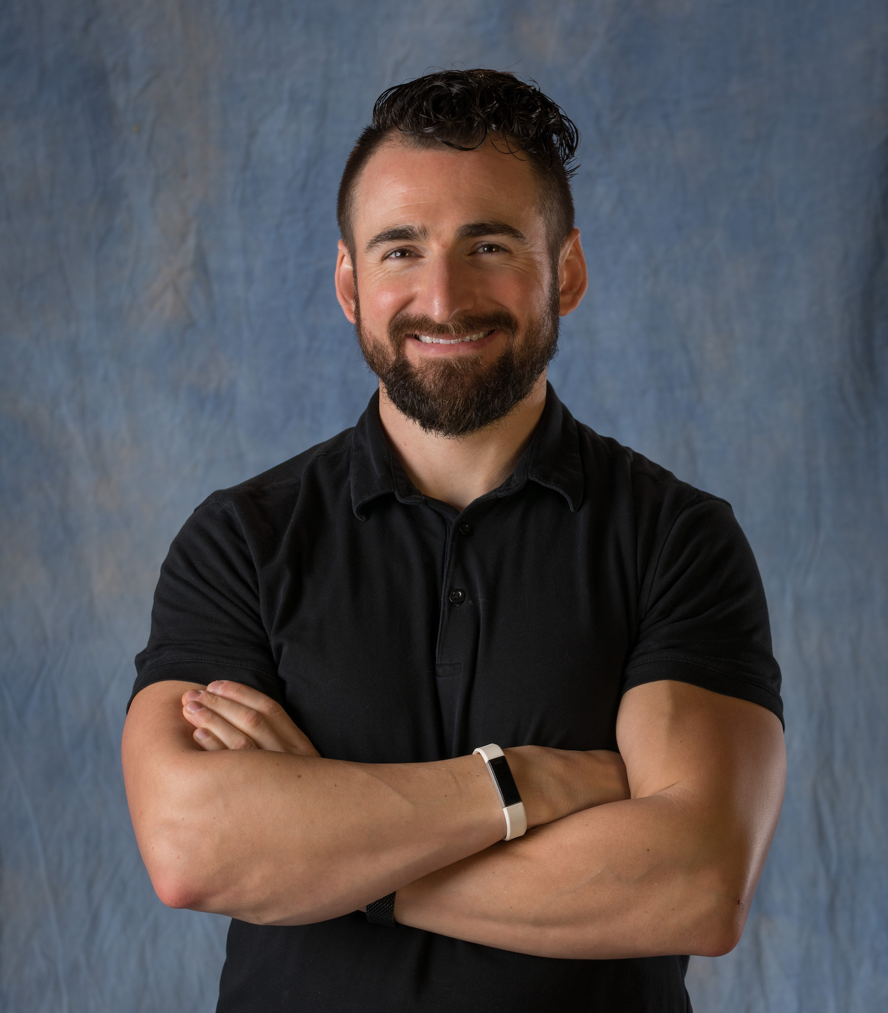

When healthcare leaders want to build healthy teams and cultivate leadership so they can save lives as they serve, they call Dr. Adam Martin. He is the founder of The Fit Pharmacist, LLC, and author of “[Rx: You: The Pharmacist's Survival Guide for Managing Stress & Fitting in Fitness](https://amzn.to/2ViCBRa)” and “[Gen-Z Pharmacist: Dominate Pharmacy School & Script Your Dream Career](https://thefitpharmacist.myshopify.com/products/pre-order-gen-z-pharmacist-dominate-pharmacy-school-script-your-dream-career)”. He works with healthcare leaders who want to leverage adversity into productivity, create impact-driven income, and solve the dilemma of work-like balance to create lasting change.

Adam has worked with healthcare organizations across the world on leadership, mental health/wellness, and building a personal brand for impact-driven income since becoming a professional speaker through the National Speakers Association in 2019. He is known as “The Tony Robbins of Healthcare” by audiences he has served through his speaking programs as a high-content trainer who dispenses strategies and tactics that are implementable immediately.

Working as the Chief Growth Officer for Blueberry Pharmacy to innovate interprofessional collaboration, the pharmacy profession has leveraged his expertise across national meetings for pharmacy student organizations as well as their conventions, conferences, and workshops. He has also presented at healthcare events hosted internationally, including the Trinity College at Dublin in Ireland, and the country’s first-ever mental health symposium in Cork, Ireland.

Thought leaders in healthcare come to him when they seek a recognized expert who still practices as a healthcare professional. He has also been called upon to present at several businesses, including wellness-oriented companies and entrepreneurial healthcare practices. He resides in Pittsburgh, with a passion to share simple solutions to healthcare’s biggest burdens on The Fit Pharmacist Healthcare Podcast. He has traveled to Panama and Honduras to work as a medical missionary pharmacist in the field, and seeks to serve the future of healthcare as a pharmacy student preceptor at the University of Pittsburgh School of Pharmacy. In 2019, he was named the ["Most Influential Pharmacist" by SingleCare's Best of the Best Pharmacy Awards](https://www.singlecare.com/blog/pharmacy-awards-winner/most-influential-pharmacist/).

Tune into weekly insights on [The Fit Pharmacist Healthcare Podcast](https://podcasts.apple.com/us/podcast/the-fit-pharmacist-healthcare-podcast/id1397266139):

[iTunes](https://podcasts.apple.com/us/podcast/the-fit-pharmacist-healthcare-podcast/id1397266139) / [Spotify](https://open.spotify.com/show/69DG59eArXAKRZf1rZST6D?si=58db4f1a77ab4707) / [iHeart Radio](https://www.iheart.com/podcast/256-the-fit-pharmacist-healthc-43091975/) / [SoundCloud](https://soundcloud.com/thefitpharmacist?utm_source=clipboard&utm_medium=text&utm_campaign=social_sharing) / [Stitcher](https://soundcloud.com/thefitpharmacist?utm_source=clipboard&utm_medium=text&utm_campaign=social_sharing)

You can connect with him on [Instagram](https://www.instagram.com/thefitpharmacist/): @thefitpharmacist

[Twitter](https://twitter.com/fitpharmfam) / [Facebook](https://www.facebook.com/fitpharmfam/) / [LinkedIn](https://www.linkedin.com/in/fitpharmfam): @FitPharmFam

[YouTube](https://www.youtube.com/thefitpharmacist): The Fit Pharmacist